# Iowa Gambling Task

# Introduction

This paper examines decision-making under imperfect circumstances – meaning that, much like in real-life situations, not all necessary information is available to the decisionmaker. Decisions are examined during two sessions of a card-drawing game in which participants can choose to draw cards from four different decks, which will either reward or punish them with virtual currency. Knowing nothing about any of the decks, the participants will have to experience the thrill of gain or the agony of loss to inform their strategy.

The original authors of the experiment, posited that participants, when presented with such complex choices, would use somatic markers to inform their decision making (Bechara, Damasio, Damasio, & Anderson, 1994; Dunn et al., 2010).

Participants are expected to learn from the results of their draws and eventually form a strategy, which would lead to more selectively drawing from profitable decks in session two, resulting in a higher end capital for this session than the first. Further, older individuals are expected to have a lower risk tolerance, leading to a higher end capital (Purves et al., 2013).

# Method

This experiment included *N* = 203 participants, all psychology students at UCPH. Sex differences were not considered.

## Materials

* Computer
* E-Prime® file containing the Iowa Gambling Task
* Headphones
* Questionnaire for reflection

## Procedure

On their computer screen, each participant was given a loan of 2000 DKK and options of four decks, A, B, C, and D to draw cards from. Once the participant drew a card, either reward or punishment was administered, and the corresponding sound effect was played. Participants did not know the number of draws they had to make. There were two sessions of 100 draws and after each session, participants were asked to estimate the size of rewards and punishments as well the frequency of punishment for each deck. Decks A and B were designed to net the same average loss while decks C and D were designed to net the same average gain.

# Results

Figure 1 displays a general preference for the lower risk decks C and D over high risk decks A and B. This preference is even more pronounced in session two, implying that participants have learnt from the results of their draws in session one, now playing more carefully.

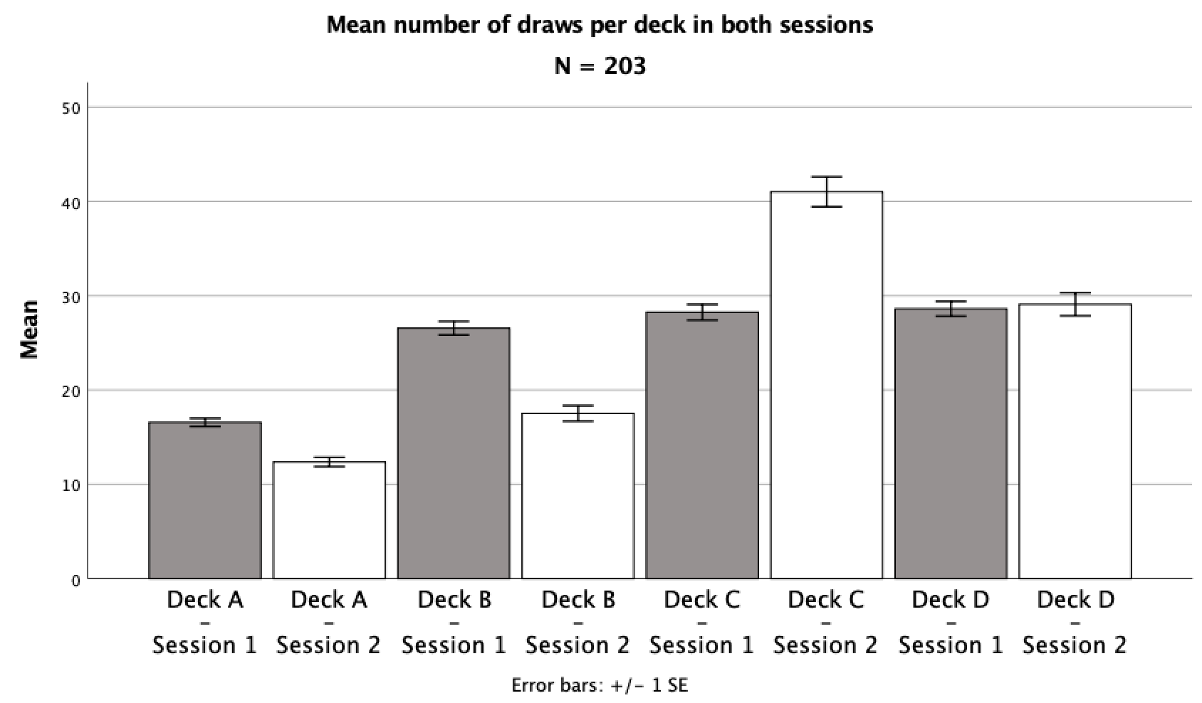

Figure 1: Bar chart showing mean number of draws from each deck in both sessions

## Learning to play safe

To test whether these differences are significant, a repeated measures ANOVA was conducted.

The test showed a significant main effect of deck on number of draws, *F*(1.96, 396.68) = 94.38, *p* < .001, $η_{p}^{2}$ = .32 (Huyhn-Feldt corrected), and a significant interaction between session and deck, *F*(1.94, 392.26) = 61.94, *p* < .001, $η_{p}^{2}$ = .24 (Huyhn-Feldt corrected).

The significant effect of deck means that participants learnt during the experiment. Further, the interaction between deck and session implies that learning is carried across from one session to the next and that participants can skip the initial testing phase in session two.

To determine whether participants generally preferred the profitable decks, paired-samples *t*-tests were conducted comparing decks A+B with C+D. The test was also run comparing end capital for the two sessions. Results and descriptive statistics are displayed in table 1.

|  |  |  |  |  |  |  |  |  |  |  |  |  |  |  |  |  |  |  |  |  |  |
| --- | --- | --- | --- | --- | --- | --- | --- | --- | --- | --- | --- | --- | --- | --- | --- | --- | --- | --- | --- | --- | --- |
| Table 1:  *Mean share of draws from decks A&B vs C&D, and end capital* | | | | | | | | | | | | | | | | | | | | | |
|  |  | *M* |  | *SD* |  | | *M* | |  | | *SD* | |  | *t*-tests | | | | | | | |
|  |  | Deck A & B | | |  | | Deck C & D | | | | | |  | *t*(202) | |  | *p* | |  | *d* | |
| Session 1 |  | 0.43 |  | (0.13) |  | | 0.57 | |  | | (0.13) | |  | 7.33 | |  | < .001 | |  | -1.03 | |
| Session 2 |  | 0.30 |  | (0.16) |  | | 0.70 | |  | | (0.16) | |  | 17.99 | |  | < .001 | |  | -2.53 | |
|  | | | | | | | | | | | | | | | | | | | | | |
|  |  | Session 1 | | |  | | Session 2 | | | | | |  | *t*(202) | |  | *p* | |  | *d* | |
| End Capital |  | 1999.88 |  | (866.07) | |  | | 2956.65 | |  | | (1291.11) | |  | 9.89 | |  | < .001 | |  | -0.89 | |
| *Note: Values for deck-variables are displayed as mean share of total draws for each session. End capital shows the mean capital in DKK at the end of each session*. | | | | | | | | | | | | | | | | | | | | | |

In session one, there are more draws from profitable decks than nonprofitable ones. This difference is significant, meaning that participants have learnt during this first session. In session two this learning is clearer with a much greater effect size, likely meaning that participants are sticking with their strategies from the beginning of session two.

Another indicator of a proficient strategy would be a higher end capital in session two over session one. This difference also proved significant, with a substantially higher mean end capital for session two (table 1).

## Comparing end capital

To test whether participants’ results differed significantly from the starting capital of 2000 DKK, which is also the expected mean end capital if all draws were made at random, one sample *t-*tests were conducted.

The *t*-tests (two-tailed, α = .05) showed a significant difference from 2000 DKK in end capital (*M* = 2956.65, *SD* = 1291.11) for session 2, *t*(202) = 10.56, *p* < .001, *d* = 0.74, but no significant difference from 2000 DKK in end capital (*M* = 1999.88, *SD* = 866.07) for session 1, *t*(202) = -0.002, *p* = .998, *d* = 0.00.

This implies that participants decided on a strategy rather late, if at all, in session one, putting their results strikingly close to that of random draws. For sessions two, participants earn a significant amount of money, meaning they have successfully employed their strategies.

To determine whether profits were generated by strategies rather than chance, an examination was made of correlations of end capital for sessions one and two.

A two-tailed Pearson’s correlation showed a significant positive correlation between end capital for session 1 and end capital for session 2, *r*(201) = .23, *p* < .001. meaning that those who did well in the first session were likely to do well in session two as well.

## Age and profit are not correlated

If risk tolerance decreases with age, one might expect to find a positive correlation between participant age and end capital for session two, as the more consistently safe participants would earn more money (Purves et al., 2013).

A two-tailed Pearson’s correlation showed no significant correlation between age and end capital for session 2, *r*(201) = .04, *p* = .60.

This does not provide evidence that older participants were more risk averse, but the nonsignificant result may be due to the narrow age group included in the sample.

## A detailed look at decisions

Investigating the individual plots for FP19201 (Figure 2, Figure 3) reveals an initial testing phase in which each deck is tested. This results in capital increasing and decreasing radically. FP19201 tests the different decks until around draw #50, at which point a net loss has been incurred, and the participant decides on a strategy. This strategy is diligently maintained throughout the rest of both experiments.

Figure 2: Graph showing capital and deck selection as a function of number of total draws for FP19201 in the first session

Figure 3: Graph showing capital and deck selection as a function of number of total draws for FP19201 in the second session

# Conclusion

Participants generally learn to draw predominantly from profitable decks, thus performing better in session two than session one. This implies that participants have learnt from the losses they incurred from decks A and B, and generally formed proficient decision-making strategies, possibly informed by the somatic experiences from losing and gaining.

# 

# References

Bechara, A., Damasio, A. R., Damasio, H., & Anderson, S. W. (1994). Insensitivity to future consequences following damage to human prefrontal cortex. *Cognition*, *50*, 7–15.

Dunn, B. D., Galton, H. C., Morgan, R., Evans, D., Oliver, C., Meyer, M., … Dalgleish, T. (2010). Listening to Your Heart: How Interoception Shapes Emotion Experience and Intuitive. *Psychological Science*, *21*(12), 1835–1844.

Purves, D., Cabeza, R., Huettel, S. A., LaBar, K. S., Platt, M. L., & Woldorff, M. G. (2013). *Principles of Cognitive Neuroscience* (2nd ed.). Sunderland, Massachusetts: Sinauer Associates, Inc., Publishers.